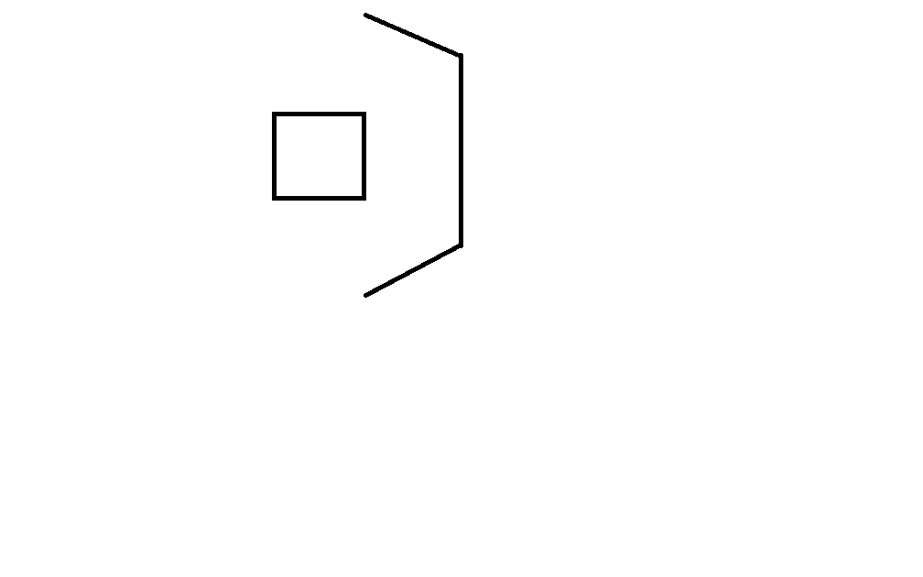

**Auto:**

Discs scored into (#):

Low Goal

Middle Goal

High Goal

Missed

**Endgame:** (check all that apply)

No climb Corner

1st level Inside

2nd level Drive on

3rd level Climb failed

Start position

Team # Match # Team: R/B

Goal

Pyramid

Tele-op:

**Strategy:** Began climb during:

Only climb Tele-op

Only shoot discs Last 30 seconds

Shoot and climb Last 5 seconds

Played defense blocks pins

Pyramid

**Tele-op:**

Discs scored into (#):

Low Goal

Middle Goal

High Goal

Pyramid Goal

Missed

Times reloaded

Mark where the robot starts

Notes:

[Type a quote from the document or the summary of an interesting point. You can position the text box anywhere in the document. Use the Drawing Tools tab to change the formatting of the pull quote text box.]

Team # Match # Team: R/B

**Auto:**

Discs scored into (#):

Low Goal

Middle Goal

High Goal

Missed

**Endgame:** (check all that apply)

No climb Corner

Drive on Inside

1st level 2nd level

3rd level Climb failed

Start position



Pyramid

Tele-op:

Goal

**Strategy:** Began climb during:

Only climb Tele-op

Only shoot discs Last 30 seconds

Shoot and climb Last 5 seconds

Played defense blocks pins

Pyramid

Mark where the robot starts

**Tele-op:**

Discs scored into (#):

Low Goal

Middle Goal

High Goal

Pyramid Goal

Missed

Times reloaded

Notes: